**Assignment 1:**

**SDLC Overview - Create a one-page infographic that outlines the SDLC phases (Requirements, Design, Implementation, Testing, Deployment), highlighting the importance of each phase and how they interconnect.**

Software Development Life Cycle (SDLC): The process of developing software through systematic steps.

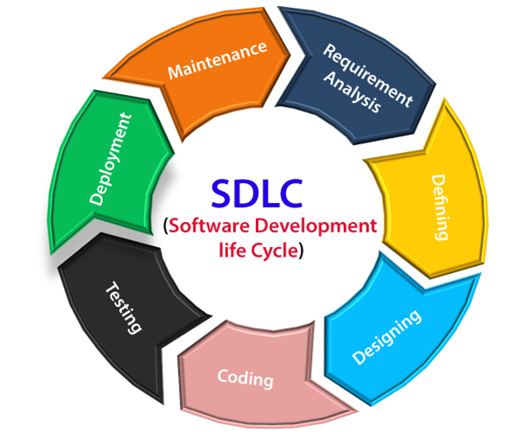

**1. Requirements**

Importance: Sets the foundation by defining user needs and system functionality.

How it Connects: Guides all subsequent phases; acts as a blueprint for development.

**2. Design**

Importance: Transforms requirements into a detailed system specification.

How it Connects: Bridges the gap between conceptualization and implementation; lays the groundwork for coding.

**3. Implementation**

Importance: Writing code based on design specifications.

How it Connects: Transforms design into a working system; follows the guidelines set by requirements and design phases.

**4. Testing**

Importance: Ensures the system meets the specified requirements and is free from defects.

How it Connects: Validates the functionality against requirements; feedback loop with design and implementation phases for adjustments.

**5. Deployment**

Importance: Delivering the final product to the end-users.

How it Connects: Marks the completion of the development process; based on successful testing outcomes.

Conclusion

Each phase of the SDLC is essential for delivering a high-quality software product. They are interconnected, with each phase building upon the results of the previous one. Proper execution of these phases ensures efficient development, minimizing errors and maximizing user satisfaction.

**Assignment 2: Develop a case study analyzing the implementation of SDLC phases in a real-world engineering project. Evaluate how Requirement Gathering, Design, Implementation, Testing, Deployment, and Maintenance contribute to project outcomes.**

Case Study: Implementation of SDLC Phases in a Real-World Engineering Project

Project Overview: Company X, a leading software development firm, embarked on a project to develop a new customer relationship management (CRM) system for a large multinational corporation. The goal was to enhance customer interactions, streamline sales processes, and improve data management.

**1. Requirement Gathering:**

During this phase, Company X collaborated closely with stakeholders from the multinational corporation to understand their business needs, challenges, and goals. Through interviews, surveys, and workshops, the team identified key requirements such as seamless integration with existing systems, customizable dashboards, and robust security measures.

Contribution to Project Outcome: Thorough requirement gathering ensured alignment between the software solution and the client's objectives, laying a solid foundation for subsequent phases. It mitigated the risk of miscommunication and scope creep, ultimately leading to a solution that met the client's expectations.

**2. Design:**

Based on the gathered requirements, Company X's design team created a comprehensive system architecture and user interface (UI) design. They developed wireframes and prototypes, incorporating feedback from both the client and internal stakeholders. The design phase aimed to ensure usability, scalability, and adherence to industry best practices.

Contribution to Project Outcome: Effective design translated the identified requirements into a tangible plan, providing a roadmap for development. Clear documentation facilitated communication across teams and guided implementation efforts. It also allowed stakeholders to visualize the end product, fostering buy-in and reducing the likelihood of misunderstandings.

**3. Implementation:**

The development team commenced coding based on the approved design specifications. They followed agile methodologies, breaking down the project into manageable sprints and regularly showcasing progress to the client. Continuous integration and version control were employed to maintain code quality and facilitate collaboration among developers.

Contribution to Project Outcome: Implementation transformed the design into a functioning CRM system, bringing the project closer to fruition. Adherence to coding standards and best practices ensured maintainability and minimized technical debt. Close collaboration with the client enabled timely feedback and adjustments, enhancing the software's alignment with evolving business needs.

**4. Testing:**

A dedicated quality assurance (QA) team conducted comprehensive testing to identify and rectify defects. Various testing techniques, including unit testing, integration testing, and user acceptance testing (UAT), were employed to validate functionality, performance, and usability. Feedback from end-users and stakeholders was incorporated iteratively.

Contribution to Project Outcome: Thorough testing ensured the reliability and robustness of the CRM system, enhancing user satisfaction and trust. Early detection and resolution of bugs minimized disruptions and rework during later stages. UAT provided valuable insights into user preferences and pain points, driving continuous improvement.

**5. Deployment:**

Upon successful testing and client approval, the CRM system was deployed to production environments. The deployment process involved careful planning, data migration, user training, and post-deployment support. Company X ensured a seamless transition, minimizing downtime and maximizing user adoption.

Contribution to Project Outcome: Smooth deployment marked the culmination of the development effort, delivering tangible benefits to the client's business operations. Effective change management and training facilitated user acceptance and utilization of the new system. Ongoing support and maintenance ensured system reliability and responsiveness to emerging requirements.

Conclusion: The implementation of SDLC phases played a pivotal role in the success of Company X's CRM project. Requirement gathering, design, implementation, testing, deployment, and maintenance collectively contributed to delivering a high-quality software solution that met the client's needs and exceeded expectations. By following a systematic approach and fostering collaboration, Company X achieved project objectives while ensuring client satisfaction and long-term viability.

This case study demonstrates how each phase of the SDLC contributes to project outcomes, emphasizing the importance of a structured and iterative approach to software development.

**Assignment 3:**

**Research and compare SDLC models suitable for engineering projects. Present findings on Waterfall, Agile, Spiral, and V-Model approaches, emphasizing their advantages, disadvantages, and applicability in different engineering contexts.**

Comparing SDLC Models for Engineering Projects

**1. Waterfall Model:**

Advantages:

Simple and Easy to Understand: Linear and sequential process flow makes it easy to comprehend and implement.

Clear Milestones: Well-defined phases with distinct deliverables provide clarity on project progress.

Documentation: Emphasizes extensive documentation at each stage, facilitating future maintenance and updates.

Disadvantages:

Limited Flexibility: Sequential nature makes it difficult to accommodate changes once a phase is completed.

Late Testing: Testing occurs only after development is complete, increasing the risk of identifying defects late in the project lifecycle.

Long Delivery Time: The rigid structure may result in longer delivery times, especially for complex projects.

Applicability: Best suited for projects with well-understood requirements and minimal expected changes, such as projects with stable technology and regulatory compliance.

**2. Agile Model:**

Advantages:

Flexibility: Iterative approach allows for frequent changes and adaptations based on feedback.

Early and Continuous Delivery: Enables early delivery of usable increments, promoting customer collaboration and satisfaction.

Continuous Improvement: Emphasizes continuous improvement through regular retrospectives and adaptation.

Disadvantages:

Complexity: Requires a high level of collaboration, communication, and coordination among team members.

Lack of Documentation: Agile prioritizes working software over comprehensive documentation, which may pose challenges for future maintenance.

Difficulty in Predicting Timeline and Cost: Due to its adaptive nature, it can be challenging to predict project timelines and costs accurately.

Applicability: Ideal for projects with evolving requirements, dynamic business environments, and where stakeholder involvement is crucial for success.

**3. Spiral Model:**

Advantages:

Risk Management: Iterative nature allows for early identification and mitigation of risks through prototyping and testing.

Flexibility: Combines elements of both waterfall and iterative development, offering flexibility in accommodating changes.

Client Feedback: Provides opportunities for regular client feedback and validation throughout the development process.

Disadvantages:

Complexity: Requires a high level of expertise and careful planning to manage the iterative cycles effectively.

Costly: Involves higher costs due to the iterative nature and potential rework required during each cycle.

Time-Consuming: The iterative cycles may prolong the development timeline, especially for large-scale projects.

Applicability: Suitable for projects with high uncertainty and complexity, where risk management and client feedback are critical for success, such as large-scale software development projects.

**4. V-Model:**

Advantages:

Traceability: Establishes a clear relationship between the requirements and corresponding test cases, ensuring thorough validation.

Early Testing: Testing activities are integrated throughout the development lifecycle, allowing for early detection and resolution of defects.

Structured Approach: Provides a structured and systematic approach to development, ensuring comprehensive coverage of requirements and testing.

Disadvantages:

Rigidity: Similar to the waterfall model, it may struggle to accommodate changes once the development process has begun.

Heavy Documentation: Emphasizes extensive documentation, which can be time-consuming and may not always add value.

Limited Flexibility: The sequential nature may limit flexibility and adaptability to changing requirements.

Applicability: Well-suited for projects with clearly defined requirements and where thorough testing and validation are paramount, such as safety-critical systems and regulatory compliance projects.

Conclusion: Each SDLC model offers distinct advantages and disadvantages, making them suitable for different engineering contexts based on project requirements, complexity, and stakeholder preferences. Waterfall is ideal for well-defined projects, Agile for dynamic environments, Spiral for high-risk projects, and V-Model for projects with stringent validation requirements. Selecting the most appropriate model requires careful consideration of these factors to ensure project success.